SIMATS ENGINEERING
ASSESSMENT TOOL 1

COURSE NAME: Artificial Intelligence COURSE CODE: CSA17

COURSE OUTCOME COVERED

CO1: Apply AI basics such as intelligent agents and uninformed search methods to solve problems effectively. (BL3)

Assessment Tool Weightage: 40%

QUESTIONS: 5 Duration : 1 Hour
Total Marks:50

Annexure A

Analytical Problem Solving

Code of Conduct:

I MUKILAN K (192511437) (Name / Reg No) certify that this submission is my original work and that I have adhered to the guidelines specified for this assessment.
I understand that any violation of academic integrity rules will result in disciplinary action.

MUKILAN K
Signature of the student:

Annexure A

Analytical Problem Solving

- Solve the Water Jug problem: you are given 2 jugs, a 4-gallon one and 3-gallon one. Neither has any measuring maker on it. There is a pump that can be used to fill the jugs with water. How can you get exactly 2 gallons of water into 4-gallon jug? Explicit assumptions: A jug can be filled from the pump, water can be poured out of a jug onto the ground, water can be poured from one jug to another and that there are no other measuring devices available.

- Find out how Mars Rover, analyse and explore the samples on Mars by answering the following questions.
- What are the percept’s for this agent?
- Characterize the operating environment.
- What are the actions the agent can take?
- How can one evaluate the performance of the agent?
- What sort of agent architecture do you think is most suitable for this agent? Why?

- Explore the search space using search strategies and formulate the problem components for the 8-Queens problem using the following information: Place 8 queens on a chessboard such that none of the queen’s attack any of the others. A configuration of 8 queens on the board as shown in the figure below, but this does not represent a solution as the queen in the first column is on the same diagonal as the queen in the last column.

- A customer wants to travel from the one location to another location using OLA Cab booking mobile application. The customer can select the any of the cab type as mini, micro, sedan, shared, prime and so on based on his comfort to reach the destination. Identify what type of problem-solving agent can be used and write the pseudocode for the above problem.

- A logistics company operates a delivery network where packages must be transported between warehouses at minimum cost. Each route between warehouses has an associated travel cost (fuel + time). The company wants to determine the least-cost path from the starting warehouse S to the destination warehouse G using the Uniform Cost Search (UCS) algorithm.

The delivery network is represented as a weighted graph:
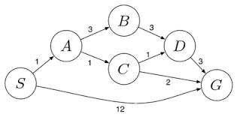

RUBRICS FOR CALCULATION:
Criteria | Weightage | Level 4 (Exemplary) | Level 3 (Proficient) | Level 2 (Developing) | Level 1 (Beginning)
Problem Understanding | 20% | Clearly interprets problem, identifies all parameters and requirements accurately | Understands problem with minor gaps | Partial understanding; misses key elements | Misinterprets or unable to understand problem
Method Selection | 20% | Selects most appropriate method/formula with strong justification | Selects correct method with minor errors | Inappropriate or partially correct method | Unable to select method
Solution Process | 25% | Logical, systematic steps with correct approach throughout | Mostly correct steps with minor mistakes | Disorganized steps; multiple errors | No clear process
Accuracy of Calculation | 20% | All calculations accurate; correct final answer | Minor calculation errors | Frequent errors; incorrect final answer | No valid calculations
Interpretation of Results | 15% | Clearly interprets results with units and engineering relevance | Basic interpretation with minor omissions | Limited or unclear interpretation | No interpretation
Problem Understanding | 20% | Clearly interprets problem, identifies all parameters and requirements accurately | Understands problem with minor gaps | Partial understanding; misses key elements | Misinterprets or unable to understand problem
Question 1: Solve the Water Jug Problem

Problem Statement:

You are given two jugs of capacities 4 gallons and 3 gallons respectively. Neither jug has any measurement markings. A water pump is available to fill the jugs completely. Water may also be poured from one jug to another until either the source jug becomes empty or the destination jug becomes full. Water may also be emptied onto the ground. The objective is to obtain exactly 2 gallons of water in the 4-gallon jug.

Introduction:

The Water Jug Problem is one of the most popular examples used in Artificial Intelligence to demonstrate problem-solving using state-space search. Every possible arrangement of water in the two jugs is considered a state, and the AI agent searches through these states until it reaches the desired goal.
This problem illustrates how an intelligent system can move systematically from an initial state to a goal state by applying valid operations. It is commonly solved using Breadth-First Search (BFS) because BFS guarantees the shortest sequence of actions.

Problem Formulation:

Initial State
- 4-gallon jug = 0 gallons
- 3-gallon jug = 0 gallons
State Representation:
(0,0)

Goal State:

The required condition is:
(2, x)
where x may be 0, 1, 2 or 3 because only the first jug must contain exactly 2 gallons.

State Representation:

Each state is represented as:
(A, B)
where
- A = amount of water in the 4-gallon jug
- B = amount of water in the 3-gallon jug
Example:
(4,1) means
- 4-gallon jug contains 4 gallons
- 3-gallon jug contains 1 gallon

Operators (Possible Actions):

The AI agent can perform the following operations:
- Fill the 4-gallon jug completely.
- Fill the 3-gallon jug completely.
- Empty the 4-gallon jug.
- Empty the 3-gallon jug.
- Pour water from the 4-gallon jug into the 3-gallon jug.
- Pour water from the 3-gallon jug into the 4-gallon jug.
These operations create transitions from one state to another until the goal state is reached.

State Space Search:

The solution path explored by the AI agent is shown below.
Step | Action Performed | State (4-gallon,3-gallon)
Initial | Both jugs empty | (0,0)
1 | Fill 3-gallon jug | (0,3)
2 | Pour into 4-gallon jug | (3,0)
3 | Fill 3-gallon jug again | (3,3)
4 | Pour into 4-gallon jug until full | (4,2)
5 | Empty 4-gallon jug | (0,2)
6 | Pour remaining 2 gallons into 4-gallon jug | (2,0)
The required goal is achieved because the 4-gallon jug now contains exactly 2 gallons.

State Transition Diagram

(0,0)
|
Fill 3-gallon
|
(0,3)
|
Pour to 4-gallon
|
(3,0)
|
Fill 3-gallon
|
(3,3)
|
Pour to 4-gallon
|
(4,2)
|
Empty 4-gallon
|
(0,2)
|
Pour to 4-gallon
|
(2,0) ← Goal State

Search Strategy Used:

The Water Jug Problem is generally solved using Breadth-First Search (BFS).
Why BFS?
- Explores states level by level.
- Guarantees the shortest sequence of actions.
- Avoids unnecessary repeated exploration by maintaining a list of visited states.
- Suitable for finite state-space problems.

State Space Representation:

The complete state space can be viewed as a graph where:
- Nodes represent water quantities.
- Edges represent legal operations.
- Initial node = (0,0)
- Goal node = (2,0)
The AI agent searches this graph systematically until the destination state is found.

Algorithm (BFS-Based):

Input: Two jugs with capacities 4 and 3 gallons.
Output: Obtain exactly 2 gallons in the 4-gallon jug.
- Start from state (0,0).
- Store the initial state in a queue.
- Mark visited states.
- Remove the first state from the queue.
- Generate all possible next states using valid operations.
- Ignore already visited states.
- Add newly generated states into the queue.
- Continue exploring until state (2,x) is found.
- Display the sequence of states.
- Stop.

Advantages:

- Produces the shortest valid solution.
- Easy to understand and implement.
- Demonstrates systematic AI problem solving.
- Useful for teaching state-space search.
- Applicable to many real-world planning problems.

Limitations:

- Memory usage increases with the number of states.
- BFS becomes inefficient for very large search spaces.
- Every possible state may need to be examined before reaching the goal.
- Not suitable for problems with extremely large branching factors.

Real-Life Applications:

The Water Jug Problem demonstrates principles used in many AI applications such as:
- Robot navigation
- Automated planning systems
- Industrial process control
- Resource allocation
- Puzzle-solving systems
- Intelligent decision support systems

Conclusion:

The Water Jug Problem is a classic Artificial Intelligence search problem that demonstrates how an intelligent agent can reach a desired goal by exploring a sequence of valid states. By representing each water configuration as a state and applying BFS, the agent systematically discovers the shortest path from the initial state (0,0) to the goal state (2,0). This problem forms the foundation for understanding state-space search techniques and intelligent problem-solving methods used in modern AI systems.
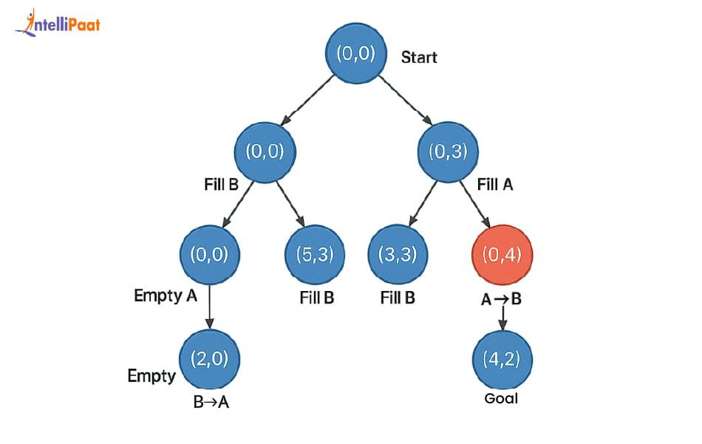

Question 2: Mars Rover as an Intelligent Agent

Introduction:

A Mars Rover is an autonomous robotic vehicle designed to travel across the surface of Mars and perform scientific investigations. Since communication between Earth and Mars experiences a delay of several minutes, the rover cannot rely on continuous human control. Instead, it uses Artificial Intelligence (AI) to perceive its surroundings, make decisions, avoid obstacles, collect samples, and accomplish its mission independently.
From an AI perspective, the Mars Rover is an Intelligent Agent because it continuously senses its environment through various sensors, processes the collected information, and performs appropriate actions to achieve its objectives.

(i) What are the Percepts for this Agent?

Definition:

Percepts are the information and observations an intelligent agent receives from its environment through sensors. They help the agent understand its surroundings before making decisions.
Percepts of the Mars Rover:

The Mars Rover gathers information using multiple sensing devices:
1. Camera Images
- Captures high-resolution images of rocks, soil and surrounding terrain.
- Helps identify interesting geological formations.
2. Surface Characteristics
- Detects hills, slopes, sand dunes and rocky regions.
- Determines whether the terrain is safe for movement.
3. Temperature Readings
- Measures atmospheric and ground temperatures.
- Helps evaluate environmental conditions.
4. Chemical Composition
- Spectrometers analyze minerals present in rocks and soil.
- Detects compounds that may indicate the presence of water or organic matter.
5. Atmospheric Information
The rover measures:
- Air pressure
- Wind speed
- Humidity (where measurable)
- Dust concentration
6. Position and Orientation
The rover constantly determines:
- Current location
- Direction of movement
- Wheel position
- Tilt angle
7. Battery Status
Internal sensors monitor:
- Remaining battery power
- Solar charging efficiency
- Energy consumption

Summary of Percepts:

Sensor | Percept Obtained
Cameras | Images of terrain and rocks
Spectrometer | Mineral composition
Temperature Sensor | Heat measurements
Navigation Sensor | Position and direction
Atmospheric Sensor | Pressure, wind and dust
Battery Monitor | Power level
These percepts collectively enable the rover to make informed decisions.

(ii) Characterize the Operating Environment:

An operating environment describes the conditions in which an intelligent agent functions.
The Mars Rover operates in a highly challenging environment that can be characterized as follows:
Partially Observable
The rover cannot observe every part of Mars simultaneously. Dust storms, hills and rocks may hide important information.
Deterministic with Minor Uncertainty
Although the rover follows programmed commands, unpredictable factors such as loose soil, wheel slippage and weather conditions introduce uncertainty.
Sequential Environment
Each action affects future decisions.
Example:
Choosing one route may consume more battery, affecting later exploration.

Dynamic Environment:

The Martian environment changes over time.
Examples include:
- Dust storms
- Temperature variations
- Moving shadows
- Changing sunlight intensity
Continuous Environment
Movement and sensor readings are continuous rather than limited to fixed values.
Unknown Environment
Many areas of Mars have never been explored before.
The rover must continuously learn about new terrain while operating.

Environment Characteristics Table:

Characteristic | Description
Observability | Partially observable
Predictability | Mostly deterministic with uncertainty
Nature | Sequential
Changes | Dynamic
State | Continuous
Knowledge | Unknown

(iii) What Actions Can the Agent Perform?

The Mars Rover performs several intelligent actions depending on the information received from its sensors.
Navigation:
- Move forward
- Reverse
- Rotate left
- Rotate right
- Stop safely

Obstacle Avoidance:
The rover detects:
- Rocks
- Deep holes
- Cliffs
- Sand traps
It automatically changes its route to avoid hazards.

Sample Collection:
The robotic arm collects:
- Soil samples
- Rock fragments
- Dust particles
These samples are examined using onboard scientific instruments.

Scientific Analysis:
The rover can:
- Drill into rocks
- Measure chemical composition
- Detect minerals
- Search for signs of ancient water

Image Capture:
The rover takes photographs for:
- Geological studies
- Navigation
- Mission documentation
Data Transmission:

Collected information is transmitted to Earth through satellites orbiting Mars.

Energy Management:
The rover intelligently:
- Monitors battery level
- Conserves energy
- Schedules scientific activities based on available power

(iv) How Can One Evaluate the Performance of the Agent?

The performance measure determines how successfully the rover completes its mission.
1. Scientific Success
- Number of useful samples collected
- Quality of scientific discoveries
- Accuracy of analysis
2. Navigation Efficiency
- Distance travelled safely
- Successful obstacle avoidance
- Route optimization
3. Mission Completion
- Number of assigned tasks completed
- Successful execution of experiments
4. Energy Efficiency
- Battery utilization
- Solar energy management
- Minimal power wastage
5. Reliability
- Ability to operate for long durations
- Recovery from unexpected situations
- Stable system performance
6. Communication Success
- Accurate transmission of scientific data
- Minimal data loss

Performance Evaluation Table:

Performance Measure | Importance
Sample Collection | Scientific research
Safe Navigation | Prevents damage
Battery Efficiency | Extends mission life
Communication | Transfers valuable data
Mission Completion | Overall success

(v) What Agent Architecture is Most Suitable? Why?

The Utility-Based Agent Architecture is the most suitable choice for the Mars Rover.

Why Utility-Based Agent?
Unlike a simple reflex agent, a utility-based agent evaluates multiple alternatives and chooses the action that provides the greatest overall benefit while considering mission goals, safety and available resources.
Decision Factors
The rover simultaneously considers:
- Distance to target
- Battery power
- Terrain difficulty
- Scientific importance
- Communication availability
- Risk of damage
The action with the highest utility value is selected.
Example
Suppose the rover has two possible paths.
Path A
- Short distance
- Rocky surface
- High chance of wheel damage
Path B
- Slightly longer distance
- Safe terrain
- Lower energy consumption
A utility-based agent selects Path B because it maximizes the overall mission success rather than simply minimizing distance.

Advantages of Utility-Based Architecture
- Makes intelligent decisions in uncertain environments.
- Balances multiple objectives simultaneously.
- Optimizes energy usage.
- Improves mission safety.
- Handles unexpected situations effectively.
- Increases the probability of long-term mission success.

Overall Working of the Mars Rover Intelligent Agent
Perceive → Interpret → Plan → Decide → Act → Evaluate

- Sensors collect environmental data.
- AI analyzes the received information.
- The rover plans the safest and most beneficial action.
- It performs the selected action.
- The outcome is evaluated.
- The cycle repeats continuously until the mission objectives are achieved.

Conclusion:

The Mars Rover is an excellent example of an AI-based intelligent agent that operates autonomously in one of the most challenging environments known to humans. By continuously collecting percepts, analyzing environmental conditions, selecting appropriate actions, and evaluating its performance, the rover successfully performs scientific exploration on Mars. A Utility-Based Agent Architecture is the most appropriate because it enables the rover to make optimal decisions by balancing safety, energy efficiency and scientific value, thereby maximizing the overall success of the mission.

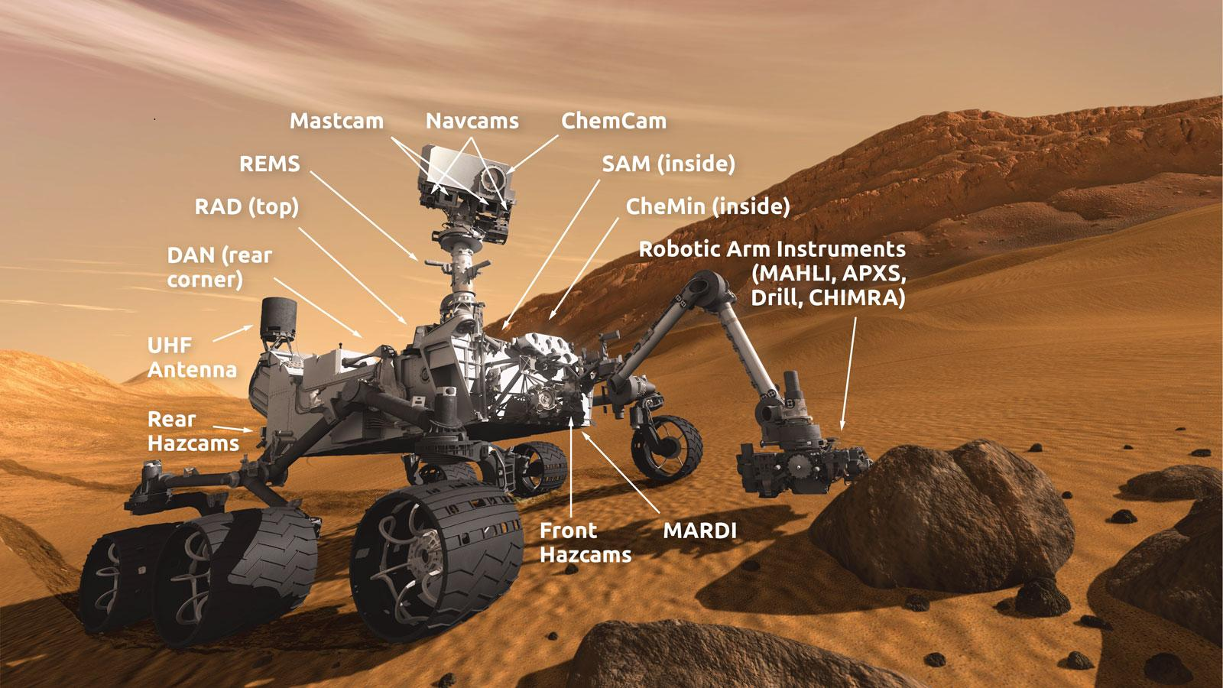

Question 3: Explore the Search Space Using Search Strategies and Formulate the Problem Components for the 8-Queens Problem

Introduction:

The 8-Queens Problem is a classical Artificial Intelligence (AI) search problem that demonstrates how intelligent agents solve constraint-based problems using search strategies. The objective is to place eight queens on a standard 8 × 8 chessboard so that no queen can attack any other queen.
In chess, a queen can move horizontally, vertically, and diagonally. Therefore, a valid solution requires that no two queens share the same row, column, or diagonal. The 8-Queens Problem is widely used to study state-space search, constraint satisfaction, and heuristic search techniques in Artificial Intelligence.

Problem Statement:

Place eight queens on an 8 × 8 chessboard such that:
- No two queens are in the same row.
- No two queens are in the same column.
- No two queens lie on the same diagonal.
The challenge is to explore different board configurations until a valid arrangement is found.

Problem Formulation:

In Artificial Intelligence, every search problem is described using five components.
1. Initial State:
The initial state is the starting configuration before any queen is placed.
Example:
- Empty chessboard
- No queens placed
. . . . . . . .
. . . . . . . .
. . . . . . . .
. . . . . . . .
. . . . . . . .
. . . . . . . .
. . . . . . . .
. . . . . . . .

2. State Space:
The state space consists of all possible arrangements of queens on the chessboard.
Each state represents a different placement of queens.
Example:
State 1
Q . . . . . . .
. . . . . . . .
. . . . . . . .
. . . . . . . .
. . . . . . . .
. . . . . . . .
. . . . . . . .
. . . . . . . .
State 2
Q . . . . . . .
. . Q . . . . .
. . . . . . . .
. . . . . . . .
...
The search algorithm explores these states until a valid solution is discovered.

3. Actions (Operators):
The possible actions are:
- Place a queen in an empty row.
- Move a queen to another safe column.
- Remove a queen during backtracking.
- Generate a new valid board configuration.
Each action transforms the current state into a new state.

4. Goal Test:
The goal is achieved when:
- Eight queens are successfully placed.
- No two queens attack each other.
The AI algorithm checks every newly generated state to determine whether it satisfies all constraints.

5. Path Cost:
Each queen placement is considered one step.
The objective is not to minimize distance but to reach a valid configuration with the fewest unnecessary explorations.

Search Space Exploration:

The AI agent explores the search space systematically.
Step 1
Place the first queen in Row 1.
Q . . . . . . .

Step 2
Move to Row 2.
Only columns that are not attacked are considered.
Q . . . . . . .
. . Q . . . . .

Step 3
Continue placing queens row by row.
Whenever a conflict occurs, the algorithm returns to the previous row and tries another position.
This process is called Backtracking.

Step 4
Continue until all eight queens are safely placed.

Search Strategies Used:

Several AI search strategies can solve the 8-Queens Problem.

1. Breadth-First Search (BFS):

Working
- Explores every possible board level by level.
- Generates all states before moving deeper.
Advantages
- Finds the shortest solution path.
- Simple to understand.
Disadvantages
- Requires very large memory.
- Slow for the 8-Queens Problem.

2. Depth-First Search (DFS):

Working
- Places queens one row at a time.
- Continues until a conflict occurs.
- Backtracks whenever necessary.
Advantages
- Uses less memory.
- Faster than BFS.
Disadvantages
- May explore many invalid branches.

3. Backtracking Search (Most Suitable):

Backtracking is the most widely used strategy.
Working
- Place a queen.
- Check whether it is safe.
- If safe, continue to the next row.
- If unsafe, move the queen.
- If no safe position exists, return to the previous row.
- Repeat until all queens are placed.
This avoids unnecessary exploration of impossible configurations.

State-Space Tree:

Start
|
Row 1
|
(Q1)
/ | \
C1 C2 C3
|
Row 2
|
(Q2)
|
Safe?
|
Yes
|
Row 3
|
...
|
Row 8
|
Goal State

Each branch represents a possible placement of a queen.
Invalid branches are discarded through backtracking.

Example of a Valid Solution:

One possible solution is:
Q . . . . . . .
. . . . Q . . .
. . . . . . . Q
. . . . . Q . .
. . Q . . . . .
. . . . . . Q .
. Q . . . . . .
. . . Q . . . .
Here:
- Every row has one queen.
- Every column has one queen.
- No diagonal conflicts exist.
Hence, this is a valid goal state.

Algorithm (Backtracking):

Input: Empty 8 × 8 chessboard
Output: Safe arrangement of eight queens
- Start with the first row.
- Place a queen in the first safe column.
- Move to the next row.
- Check row, column and diagonal safety.
- If safe, place the queen.
- Otherwise, try another column.
- If no column is safe, backtrack.
- Repeat until eight queens are placed.
- Display the final board.

Applications of the 8-Queens Problem:

The concepts used in the 8-Queens Problem are applied in many AI domains:
- Task scheduling
- Timetable generation
- Resource allocation
- Robot motion planning
- Network optimization
- Circuit board design
- Constraint Satisfaction Problems (CSP)

Advantages:

- Demonstrates state-space search effectively.
- Improves understanding of constraint satisfaction.
- Efficiently solved using backtracking.
- Helps compare different search algorithms.
- Forms the basis for solving complex optimization problems.

Limitations:

- Search space increases rapidly for larger chessboards.
- BFS requires excessive memory.
- DFS may explore many unsuccessful paths.
- Computational complexity grows with the number of queens.

Conclusion:

The 8-Queens Problem is one of the most significant examples of constraint-based problem solving in Artificial Intelligence. It illustrates how an intelligent agent formulates a problem using the components of state-space search and explores different configurations through search strategies. Among the available techniques, Backtracking Search is the most suitable because it eliminates invalid solutions early, reduces unnecessary computation, and efficiently finds a valid arrangement of eight queens. This problem has become a foundation for understanding modern AI search algorithms and real-world optimization problems.
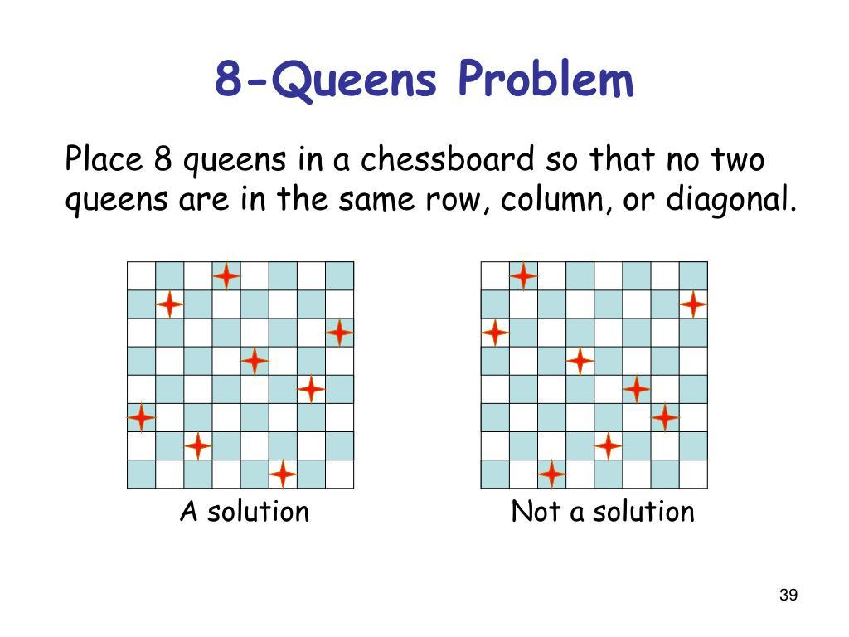
Question 4: Identify the Type of Problem-Solving Agent Used in the OLA Cab Booking Application and Write the Pseudocode

Introduction:

Online cab booking applications such as OLA have transformed urban transportation by enabling users to book rides through mobile devices. When a customer enters the pickup and destination locations, the application intelligently selects suitable cabs based on several factors such as availability, travel distance, estimated fare, traffic conditions, waiting time, and customer preferences.
From an Artificial Intelligence (AI) perspective, the OLA application functions as a Problem-Solving Agent because it receives user input, analyzes the available options, searches for the most appropriate solution, and recommends the best cab to satisfy the user's travel requirements.

Type of Problem-Solving Agent:

The most appropriate AI agent for this scenario is a Goal-Based Problem-Solving Agent.
A Goal-Based Agent chooses its actions based on a clearly defined objective. In the OLA application, the primary goal is to transport the customer safely and efficiently from the source location to the destination while considering user preferences.
Unlike a Simple Reflex Agent, which reacts only to the current input, a Goal-Based Agent evaluates different alternatives before making a decision. It searches through available cab options and identifies the one that best achieves the customer's objective.

Why Goal-Based Agent is Suitable:

The OLA booking system satisfies the characteristics of a Goal-Based Agent because it:
- Accepts the customer's travel request.
- Searches for nearby available drivers.
- Evaluates multiple cab categories.
- Estimates travel time and fare.
- Suggests the most appropriate ride.
- Continuously updates information if conditions change.
Thus, the system makes decisions by considering the desired goal rather than responding to a single condition.

Problem Formulation:

Artificial Intelligence represents the booking process using the following components.

1. Initial State:

- Customer opens the OLA application.
- Pickup and destination locations are not yet entered.
- No cab has been assigned.

2. State Space:

The state space consists of all possible booking situations, including:
- Different cab types (Mini, Micro, Sedan, Prime, Shared, etc.)
- Various driver locations
- Multiple travel routes
- Different fare estimates
- Traffic conditions
- Driver availability
Each possible booking combination represents a unique state.

3. Actions:

The agent performs several actions, including:
- Accept pickup location.
- Accept destination.
- Search nearby drivers.
- Display available cab categories.
- Estimate fare.
- Estimate travel time.
- Compare available rides.
- Book selected cab.
- Notify the assigned driver.
- Track the ride until completion.

4. Goal State:

The goal is achieved when:
- A suitable cab is successfully assigned.
- The customer reaches the destination safely.
- Payment is completed.
- Ride status becomes Completed.

5. Path Cost:

The booking system attempts to minimize:
- Waiting time
- Travel distance
- Total fare
- Traffic delays
- Fuel consumption
The best solution is the one that provides maximum customer satisfaction with minimum overall cost.

Working of the Goal-Based Agent:

The OLA AI agent follows a sequence of intelligent steps.

Step 1: Receive Request

The customer enters:
- Pickup location
- Destination

Step 2: Search Available Drivers

The system checks:
- Driver availability
- Driver location
- Cab category
- Driver status

Step 3: Evaluate Available Options

Each available cab is evaluated using parameters such as:
- Estimated fare
- Distance from customer
- Estimated arrival time
- Traffic conditions
- Customer preferences

Step 4: Present Available Choices

The application displays different ride options such as:
- Micro
- Mini
- Sedan
- Prime
- Shared
Each option includes fare, arrival time, and vehicle details.

Step 5: Booking Confirmation

After the customer selects a cab:
- Driver receives booking request.
- Driver accepts the ride.
- Navigation begins.
- Customer can track the cab in real time.

Step 6: Ride Completion

The ride ends after reaching the destination.
The application then:
- Calculates the final fare.
- Processes payment.
- Requests customer feedback.
- Stores trip history.

AI Search Process:

The OLA application performs a search similar to an AI search problem.

Customer Request
│
▼
Collect Pickup & Destination
│
▼
Search Available Drivers
│
▼
Evaluate Multiple Cab Options
│
▼
Select Best Cab
│
▼
Assign Driver
│
▼
Navigate to Destination
│
▼
Ride Completed

Pseudocode:

Algorithm OLA_Cab_Booking

Start

Input Pickup_Location

Input Destination

Search Available_Drivers

If No Driver Available
Display "No Cabs Available"
Stop
End If

Display Available Cab Types

(Micro, Mini, Sedan, Prime, Shared)

Calculate Fare

Estimate Arrival Time

Customer Selects Cab

Assign Nearest Driver

If Driver Accepts

Confirm Booking

Start Navigation

Track Ride

Reach Destination

Calculate Final Fare

Process Payment

Display "Ride Completed"

Else

Search Next Available Driver

End If

Stop

Performance Measure:

The success of the OLA AI agent is evaluated using the following criteria:

Performance Measure | Purpose
Short waiting time | Improves customer convenience
Accurate fare estimation | Builds customer trust
Fast driver assignment | Reduces booking delay
Safe navigation | Ensures passenger safety
Successful trip completion | Achieves booking goal
Customer rating | Measures service quality

Advantages:

- Quickly identifies nearby drivers.
- Provides multiple travel options.
- Reduces passenger waiting time.
- Optimizes travel routes.
- Improves customer convenience.
- Supports real-time ride tracking.
- Uses intelligent decision-making for better service.

Limitations:

- Dependent on internet connectivity.
- Traffic congestion may increase travel time.
- Surge pricing during peak hours.
- GPS inaccuracies can affect pickup location.
- Ride availability may be limited in remote areas.

Real-World Applications:

The concept of Goal-Based Problem-Solving Agents is used in:
- Ride-sharing applications
- Food delivery platforms
- Online ticket booking systems
- Warehouse logistics
- Robot navigation
- Autonomous delivery vehicles
- Smart transportation systems

Conclusion:

The OLA Cab Booking application is an excellent example of a Goal-Based Problem-Solving Agent in Artificial Intelligence. It intelligently analyzes customer requirements, evaluates multiple ride alternatives, and selects the most suitable cab to achieve the desired destination efficiently. By integrating search techniques, decision-making, route optimization, and real-time monitoring, the system provides a reliable and user-friendly transportation service while maximizing customer satisfaction.
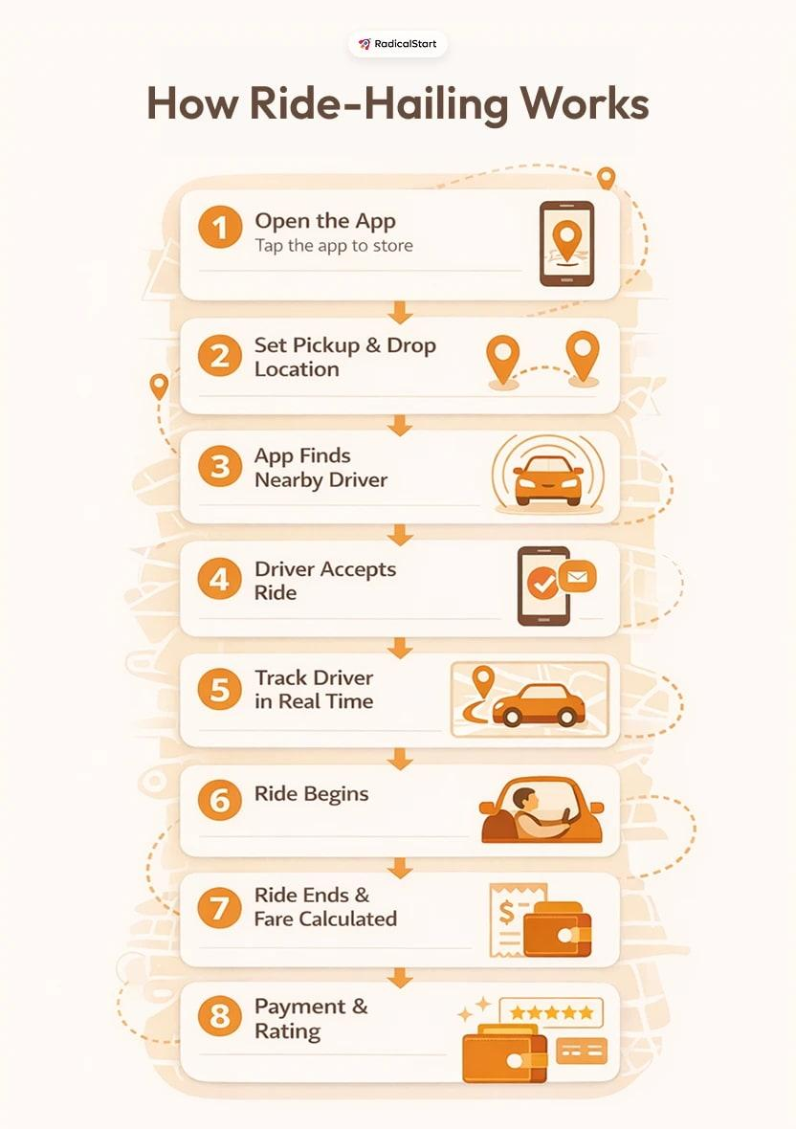
Question 5: Determine the Least-Cost Path Using the Uniform Cost Search (UCS) Algorithm

Introduction:
In Artificial Intelligence, many real-world problems require finding the least expensive path rather than simply the shortest path. Examples include delivery services, GPS navigation, airline route planning, and warehouse logistics. These problems are solved using Uniform Cost Search (UCS), an informed search strategy that always expands the node with the lowest cumulative path cost.
In the given scenario, a logistics company wants to transport packages from the starting warehouse (S) to the destination warehouse (G) while minimizing the total transportation cost, which includes fuel expenses and travel time. Uniform Cost Search is an ideal algorithm because it guarantees the optimal (minimum-cost) solution when all route costs are non-negative.

What is Uniform Cost Search (UCS)?

Uniform Cost Search (UCS) is a search algorithm that explores nodes based on the lowest accumulated cost from the starting node rather than the number of steps. It uses a Priority Queue to ensure that the next node selected for expansion is always the one with the smallest path cost.
Unlike Breadth-First Search, UCS considers edge weights, making it suitable for weighted graphs where different routes have different travel costs.

Problem Formulation
The logistics routing problem can be represented using the following AI components.

1. Initial State:

- Starting warehouse: S
- Delivery vehicle is ready to transport the package.

2. State Space:

The state space includes every warehouse that can be reached from the starting warehouse.
Each warehouse represents a state, and every road connecting two warehouses represents a transition.
Example:
S → A → B → C → D → G
The algorithm explores these possible routes while keeping track of the total travel cost.

3. Actions:

Possible actions include:

- Move from one warehouse to another.
- Expand the lowest-cost route.
- Update cumulative travel cost.
- Select the next warehouse with minimum cost.
- Continue until the destination warehouse is reached.

4. Goal State:

The goal is achieved when the destination warehouse G is removed from the priority queue for expansion.
At this stage, UCS guarantees that the path obtained has the minimum total cost.

5. Path Cost:

The path cost is the sum of all edge costs along the selected route.
[
\text{Total Cost} = \sum \text{(Cost of each travelled edge)}
]
The algorithm always chooses the path having the smallest cumulative cost.

Working Principle of Uniform Cost Search:

Uniform Cost Search follows the principle of "Expand the cheapest path first."

The algorithm repeatedly performs the following operations:

- Insert the starting node into the priority queue with cost 0.
- Remove the node having the minimum cumulative cost.
- Check whether it is the goal.
- If not, expand all neighboring nodes.
- Calculate new cumulative costs.
- Insert or update neighbors in the priority queue.
- Repeat until the destination node is reached.
Because the priority queue is ordered by cumulative cost, the first time the goal node is selected, the obtained path is guaranteed to be optimal.

Example
Consider the following weighted graph.
4
S ------- A
| |
2 | | 5
| |
B ------- C
\ /
6 \ / 3
\ /
G
Step 1
Start from node S.
Priority Queue:
S (0)

Step 2
Expand S
Available paths:
S → B = 2
S → A = 4
Priority Queue:
B (2)
A (4)

Step 3
Expand B
New path:
S → B → G = 8
S → B → C = 7
Priority Queue:
A (4)
C (7)
G (8)

Step 4
Expand A
New path:
S → A → C = 9
Existing path to C = 7
Since 7 is smaller than 9, UCS keeps the cheaper path.
Priority Queue:
C (7)
G (8)

Step 5
Expand C
New path:
S → B → C → G
Cost = 10
Existing cost to G = 8
Since 8 is smaller, no update is made.
Priority Queue:
G (8)

Step 6
Expand G
Goal reached.
Optimal path:
S → B → G
Total Cost:
8

Search Process:

Start (S)
│
▼
Insert into Priority Queue
│
▼
Expand Lowest Cost Node
│
▼
Goal Reached?
│ │
No Yes
│ │
Expand Stop
Neighbours
│
▼
Update Costs
│
▼
Insert into Priority Queue
│
└──────────Repeat───────────

Pseudocode:

Algorithm UniformCostSearch(Graph, Start, Goal)

Create Priority Queue

Insert Start with Cost = 0

While Queue is not Empty

Remove Node with Minimum Cost

If Node == Goal

Return Path

End If

For Each Neighbour

NewCost = CurrentCost + EdgeCost

If NewCost is Smaller

Update Cost

Insert into Priority Queue

End If

End For

End While

Return Failure

Characteristics of UCS:

- Uses a Priority Queue.
- Expands the least-cost node first.
- Guarantees the optimal solution.
- Works with weighted graphs.
- Complete when edge costs are positive.
- Suitable for logistics and route optimization.

Applications:

Uniform Cost Search is widely used in:

- Logistics and supply chain management
- GPS navigation systems
- Airline route planning
- Robot path planning
- Network routing protocols
- Smart transportation systems
- Autonomous delivery vehicles
- Warehouse management

Advantages:

- Always finds the minimum-cost path.
- Suitable for weighted graphs.
- Produces optimal solutions.
- Efficient for transportation and routing problems.
- Avoids selecting expensive routes unnecessarily.

Limitations:

- May consume more memory for large graphs.
- Slower than BFS when all edge costs are equal.
- Requires all edge costs to be non-negative.
- Performance decreases as the number of nodes increases.

Difference Between BFS and UCS:
Breadth-First Search | Uniform Cost Search
Expands level by level | Expands least-cost path first
Ignores edge weights | Considers edge weights
Uses Queue | Uses Priority Queue
Suitable for unweighted graphs | Suitable for weighted graphs
Does not always produce minimum-cost solution | Always produces minimum-cost solution

Conclusion:

Uniform Cost Search (UCS) is one of the most effective search algorithms in Artificial Intelligence for solving minimum-cost path problems. By expanding nodes according to their cumulative travel cost rather than the number of steps, UCS guarantees an optimal solution whenever route costs are positive. In the logistics warehouse scenario, UCS enables the company to identify the most economical delivery route, reducing transportation expenses, improving operational efficiency, and ensuring timely package delivery. Therefore, UCS plays a vital role in modern AI applications involving navigation, transportation, and resource optimization.

